

**Success in Mind**

Project website:

<https://you.stonybrook.edu/sportspsych1/>

Software Design Document

Spring 2021

**Team Member Information**

Jiaji Zhang (Leader) [jiaji.zhang@stonybrook.edu](mailto:jiaji.zhang@stonybrook.edu) 631-428-6395

Jianfeng Peng (Researcher) jianfeng.peng@stonybrook.edu 929-293-3950

Sisi Chen (Secretary) sisi.chen.1@stonybrook.edu 516-675-8324

**Client Information**

Dr. Bowman

Sport Psychologist at SBU

jjb@mindplusmuscle.com

631-513-3632

**I. Introduction**

**Project Description:**

Success in Mind is an app designed to enhance the interaction between athletes and athletic

trainers in sports psychology training sessions at Stony Brook University. Success in Mind

interacts with the sports psychology website to collect user data and conduct data analysis.

**Objective:**

The objective of the project is to design an easy navigation application for the user to record a

self-direct weekly plan, access the overall summary page, and conduct sports psychology

consultation. Development is focused on the design of the app interface, data collection, and data analysis.

**Brief Description:**

It is an Android mobile app that collects data and gives feedback for students and coaches

and it is available for all Android users. The app is intended for Stony Brook University

athletes and coaches, but it can be used outside Stony Brook University. We use the google

flutter app to create the app because the code can be written once and it runs everywhere.

Flutter gives a lot of modularity since we can add and change codebase easily.

**II. Functional Description**

* Connect with success in mind website to retrieve mental fitness assessment grade
* Log in or sign up to use the app
* Audio tutorial of how to use the app to record the data and get the summary
* Input weekly success plan, weekly journal page
* Submit each journal to directed coaches or trainers
* Data summary page

**III. Data Design**

**Data Description**

By simply answering the questions from the app and clicking submit, the answer will be recorded to Firebase. In the summary page, you can see the feedback and analysis of how you are doing. Of course, you can change the code and connect to the other database.

**Data Dictionary**

Weekly Success Plan: fields:

1. vision (String)

2. training goals (int)

3. mental fitness goals (int)

4. course work goals (int)

5. recreational goals (int)

6. goal for overall performance rating (int)

7. goal for level of satisfaction (int)

- Daily Success Journal: fields:

1. training goals (bool)

2. mental fitness goals (bool)

3. course work goals (bool)

4. recreation goals (bool)

5. awesome performance (String)

6. great practice (String)

7. feeling happy (String)

8. feeling confident (String)

9. good rest (String)

**IV. Human Interface Design**

**Overview**

The app contains a landing page, login page, and main operation pages. The operation page can be accessed and users can be directed to each page by using the menu bar. The theme colors are orange and blue because they are complementary colors and work well together. Because the app is designed for Stony Brook University students, we added school elements to the app such as the school logo.

**Screen Objects and Actions**



Dr. B’s cartoon figure. By clicking the play button, users can access the audio tutorial.

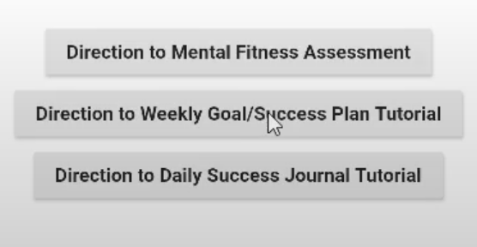

Direction buttons. Can direct users to specific page both within the app or specific website

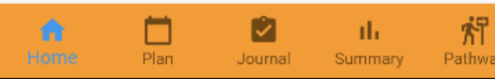

Menu bar. Directed users to each page.

**Installation of Flutter (Mac and PC):**

The minimum system required to install flutter:

*Mac:*

* Operating Systems: macOS (64-bit)
* Disk Space: 2.8 GB (does not include disk space for IDE/tools).

*Windows:*

* Operating Systems: Windows 7 SP1 or later (64-bit), x86-64 based
* Disk Space: 1.64 GB (does not include disk space for IDE/tools).

Installation method:

*Windows:*

1. <https://flutter.dev/docs/get-started/install> using this link to get Flutter SDK
2. Download Git
3. Extract the zip file and place the contained flutter in the desired installation location for the Flutter SDK (for example, C:\src\flutter). Remember not to install Flutter in a directory like C:\Program Files\ that requires elevated privileges.
4. After flutter is installed, we need to Update the path: From the Start search bar, enter ‘env’ and select Edit environment variables for your account.
5. Under User variables check if there is an entry called Path:
6. If the entry exists, append the full path to flutter\bin using ; as a separator from existing values.
7. If the entry doesn’t exist, create a new user variable named Path with the full path to flutter\bin as its value.

*Mac:*

1. <https://flutter.dev/docs/get-started/install> using this link to get Flutter SDK
2. Extract the file and move the installed flutter folder outside the downloads folder and move to somewhere permanent.
3. Open terminal.app
4. After the username and dollar sign, type ‘vim .zshrc’ and hit enter
5. Then, update the path by typing export PATH="$PATH:[PATH_OF_FLUTTER_GIT_DIRECTORY]/bin" (PATH_OF_FLUTTER_GIT_DIRECTORY means to type your own path to flutter folder)
6. Then, type ‘:wq!’ which saves the file and quit the file

**Installation of Emulator:**

1. Open android studio and create a new flutter project
2. Create virtual device: open ADV Manager—click create virtual device—choose a device definition(recommend Nexus 6)—select a system image and download it (recommend Pie)—choose ‘hardware’ for graphics
3. After creating the new virtual device, we can click the play button to launch the device

**Installation of Android Studio:**

1. <https://flutter.dev/docs/get-started/install/windows#install-android-studio> use this link to download android studio
2. After download the android studio, we need to add the flutter and dart plugin to the android studio
3. After open the welcome screen, click configure—preferences—plugins tab—browse repositories—search ‘flutter’ and install it to the android studio—restart android studio
4. Now we can start a new flutter project by using android studio

**Connecting of Firebase:**

1. <https://firebase.google.com/> use this link to go to firebase
2. Click **add project** to create a new project
3. Enter a name and use the default setting of choices
4. Select the **Android** icon and follow the steps to finish connecting to Android studio.
5. Create Firebase Authentication and Firestore Database in order to enable the use of Authentication and the Database.
6. In the Rules, change “allow read, write: if false;” to “allow read, write: if true;”
7. Now we are ready to connect the app to Firebase.

**Screen Images:**

**Watch the video for details on how to use the app.**

